MINISTRY OF AGRICULTURE, FORESTRY AND WATER ECONOMY
IPARD MANAGING AUTHORITY

ANNUAL REPORT ON THE IMPLEMENTATION OF THE
IPARD 2014-2020 PROGRAMME FOR 2018

(according to Article 59 of the Sectoral Agreement)

Mаy, 2019

Contents:
1. Preface 3
2. Change in the general conditions of relevance to the implementation of the IPARD II programme 4
2.1. Political and institutional framework 4
2.2. Macroeconomic situation 4
2.3. Demographic situation 5
2.4. Agricultural production and economy 5
2.5. Changes in national and sectoral policies 9
2.6. National support schemes 9
3. Assessment of the progress in the implementation of objectives, priorities, measures and group of investments 11
3.1. Summary of the strategic framework of the IPARD Programme 2014-2020 11
3.2. Analysis on progress in implementation by measure 11
3.3. Measure 1 – Investments in physical assets of agricultural holdings 12
3.4. Measure 3 – Investments in physical assets concerning processing and marketing of agricultural and fishery products 15
3.5. Measure 7 – Farm diversification and business development 16
3.6. Geographical analysis of IPARD Programme implementation 19
4. Actions undertaken for improvement of quality and efficiency of IPARD implementation 21
4.1. Activities undertaken by the Managing Authority 21
4.2. Activities undertaken by NAO and NF 21
4.3. Activities undertaken by the IPARD Agency 28
4.4. Report on the work of the IPARD Monitoring Committee 31
4.5. Evaluation of the IPARD Programme 31
4.6. The use of Technical Assistance 33
4.7. Implementation of the Communication Plan 33
5. Coordination of IPARD funds with national funding, other IPA components, IFI’s and donor support 36

List of tables:
Table 1: Main macroeconomic indicators 5
Table 2: Agricultural areas by category of use in 000 hectares 7
Table 3: Average net salary by employee in € 9
Table 4: Employees in agriculture, forestry and fisheries 9
Table 5: Total trade and trade with agricultural and fishery products 2014-2018 (in million €) 9
Table 6: Amounts of support (in €) by the Programme for direct payments 12
Table 7: Amounts of support (in €) by the Programme for rural development 12
Table 8: Budget of EU Contribution by measure 2014-2020, in € 13
Table 9: Overview of implementation of IPARD per public calls in € 14
Table 10: Indicators on quality of implementation 14
Table 11: Overview of objectives fulfilment by applications in Measure 1 15
Table 12: Review of applications per priority sectors in Measure 1 16
Table 13: Overview of objectives fulfilment by applications in Measure 3 18
Table 14: Review of applications per priority sectors in Measure 3 19
Table 15: Overview of objectives fulfilment by applications in Measure 7 20
Table 16: Review of applications per priority sectors in Measure 7 21
Table 17: Review of applications per Municipalties 23

List of figures:
Figure 1: Structure of total population by age groups, 2015 7
Figure 2: Development of Macedonian agricultural trade (in million €), 2014-2018 period 10
Figure 3: Review of applications per value of investments in Measure 1 15
Figure 4: Review of applications per production culture in Measure 1 16
Figure 5: Review of applications per type of investment in Measure 1 17
Figure 6: Review of applications per value of investments in Measure 3 18
Figure 7: Review of applications per type of investment in Measure 3 19
Figure 8: Review of applications per value of investments in Measure 7 20
Figure 9: Review of applications per type of investment in Measure 7 21
Figure 10: Review of the applications by statistical regions 22
Figure 11: Review of the total public expenditure by statistical regions 22

- Preface
The IPARD Programme for the 2014-2020 programming period was approved on 13th of February 2015 by Commission Decision C (2015) 760.
The indicative maximum amounts of the European Union contribution for the implementation of the IPARD Programme under IPA II are set out as follows:
Year | 2014 | 2015 indicative amount | 2016 indicative amount | 2017 indicative amount | 2018 indicative amount | 2019 indicative amount | 2020 indicative amount
Total | 5,000,000 | 5,000,000 | 5,000,000 | 6,000,000 | 10,000,000 | 14,000,000 | 15,000,000

IPARD Programme 2014-2020 provides support through five measures (four of them accredited in the past programming period):
- Investments in physical assets of agricultural holdings – Measure 1,
- Investments in physical assets concerning processing and marketing of agricultural and fishery products – Measure 3,
- Investments in rural public infrastructure – Measure 5,
- Farm diversification and business development – Measure 7,
- Technical assistance – Measure 9.
The Implementation of the Programme started with announcement of the first call (01/2017) in April 2017. To meet the needs of the applicants, the final date for submission of applications under this call was extended until 21st of July. Public call 01/2018 announced in November 2018 was for submission of applications under measure 3. Public call 02/2018 opened late in December 2018 for submitting applications only under measure 1.

- Change in the general conditions of relevance to the implementation of the IPARD II programme

  - Political and institutional framework
Since the approval of the IPARD Programmе 2014-2020 to the end of the period covered by this report, significant changes in the context of the political and institutional framework have occurred. The political crisis that marked the end of the implementation of IPARD 1 resulted in changes in government. The period of political uncertainty and the prolongation of establishing a new government was challenging on many levels and slowed down the normal functioning of the institutions and processes, including some aspects of the implementation of the Programme. New top management has been appointed in all IPARD structures.
One of the more important determinants that largely reflects on the political context of the country is the entry into force of the Prespa Agreement, which resolves a long-standing foreign policy problem and opens up European perspectives.
In April 2018, the Commission published the regular progress report for Republic of North Macedonia, stating that no progress has been made to improve data quality and relevance of the farm register and LPIS. Current structures and resources at MAFWE and the IPARD Agency remained insufficient to operate and maintain IACS (a robust control system). The country needs to clarify the role of the Ministry and the IPARD Agency for operation and maintenance of the IACS. The ability to absorb funding under IPARD II remains challenged by incomplete applications and lengthy contracting process. The constant decrease and high turnover of staff in the Managing Authority and in the IPARD Agency continue to be an issue of serious concern.
  - Macroeconomic situation
Data and reports published by relevant institutions show that the economy remains stable, but the pace of growth again is rated as unsatisfactory, affected by increased political uncertainty.
Table 1: Main macroeconomic indicators
 | 2012 | 2013 | 2014 | 2015 | 2016 | 2017
GDP in million € (at current exchange rate) | 7,585 | 8,150 | 8,562 | 9,072 | 9,657 | 10,026
GDP per capita in € (at current exchange rate) | 3,680 | 3,948 | 4,141 | 4,382 | 4,659 | 4,831
GDP real growth rate (in %) | -0.5 | 2.9 | 3.6 | 3.9 | 2.8 | 0.2
Inflation (in %) | 4.7 | 1.4 | -0.5 | -0.4 | -0.2 | 2.4
Average exchange rate (denar/€) | 61.53 | 61.58 | 61.62 | 61.61 | 61.60 | 61.57
Unemployment rate (in %) | 31.0 | 29.0 | 28.0 | 26.1 | 23.7 | 22.4
Export of goods and services in mill. € | 3,124 | 3,235 | 3.747 | 4,088 | 4,390 | 5,019
Import of goods and services in mill. € | 5,071 | 4,983 | 5.505 | 5,801 | 6,176 | 6,835
Balance of trade in mill. € | -1,947 | -1.748 | -1,758 | -1,714 | -1,786 | -1,816
Balance of trade in % of GDP | -25.7 | -21.4 | -20.5 | -18.9 | -18.5 | -18.0
Source: State statistical office (SSO), National Bank of Republic of North Macedonia (NBRNM)
According to the State Statistical Office data, the industrial production volume index in February 2019, in comparison with February 2018, was 107.3. The industrial production in the section Mining and Quarrying in February 2019, in comparison with February 2018, increased by 2.9%, in the section Manufacturing it increased by 7.3%, while in the section Electricity, Gas, Steam and Air Conditioning supply it increased by 4.8%.
Increase in the section Manufacturing is mostly due to the increased production in the divisions Manufacture of Food Products, Manufacture of Beverages, Manufacture of Tobacco Products, Manufacture of Textiles, Manufacture of Basic Pharmaceutical Product and Pharmaceutical Preparations, Manufacture of Other Non-metallic Mineral Products, Manufacture of Basic Metals, Manufacture of Electrical Equipment, Manufacture of Machinery and Equipment n.e.c. and Manufacture of Motor Vehicles, Trailers and Semi-trailers.
  - Demographic situation
According to the population assessment (as of 31.12.2015), the Republic of North Macedonia has 2,071,278 inhabitants, which is 13,994 persons or 0.7% more than in 2010 and 32,764 people or 1.6% more than in 2005. In the period from 2005 to 2015 shows continuous increase in immigrant foreigners in the country.
In terms of age structure, the Macedonian population is aging. From 2005 to 2015, the share of young population (0-14 years) in total decreased from 19.4% to 16.7% and the share of the elderly population (65 and over) increased from 11.1% to 13.0%.
The demographic indicators at the regional level show differences that point to a disproportion in the territorial distribution of the population. The Skopje Region, as the most densely populated, has almost ten times higher density than the Vardar Region, which is the least densely populated. There are also differences in the age structure of the population. The highest share of young population (0-14) was registered in Skopje, Polog and the Northeast Region, while the highest proportion of old population (65+) was observed in Pelagonia, Vardar and the East Region. The indicators of the population average age also confirm this situation.
Differences are also visible in the number of births and deaths. In the Pelagonia, the Vardar and the East Region, as a result of the unfavourable age structure and the low fertility, the number of deaths exceeds the number of births.

Figure 1: Structure of total population by age groups, 2015
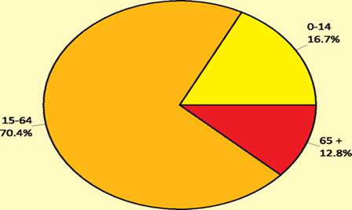
Source: SSO
  - Agriculture production and economy
Agriculture, along with Hunting, Forestry and Fisheries with a share of 10.6% in the overall Gross Domestic Product (GDP) in 2016 was the fourth largest economy sector, immediately after the sectors of Services, Industry and Wholesale and Retail Trade. Food, Beverages and Tobacco participated with 40.0% in the total consumption per household.
Economic Accounts and value of agriculture production
Gross value added in agriculture for 2017 was 44,907 million denars and in comparison with 2016 it nominally decreased by 12.8%.
Crop production in 2017, having a 65.0% share in the total production, decreased by 13.6% compared with 2016. Livestock production, accounting for 24.2% of the total production, decreased by 2.8% compared with 2016.
Intermediate consumption recorded a 4.8% decrease in 2017 compared with 2016. In 2017, the nominal income in agriculture from production factors per labour unit registered a decrease of 5.7%, while the real income in agriculture from production factors registered a decrease of 5.0%.
Agricultural land and farm structure
According to the SSO data, 1,266 million ha or 49% of the total area is agricultural land (cultivated land and pastures), 38% are under forests, while about 13% are water and other surfaces.
Table 2: Agricultural areas by category of use in 000 hectares
 | 2012 | 2013 | 2014 | 2015 | 2016 | 2017
Agricultural land | 1,268 | 1,261 | 1,263 | 1,264 | 1,267 | 1,266
- Cultivated land | 510 | 509 | 511 | 514 | 516 | 517
- Arable land and gardens | 414 | 413 | 413 | 415 | 417 | 417
- Orchards | 15 | 15 | 15 | 16 | 16 | 16
- Vineyards | 21 | 22 | 23 | 23 | 24 | 24
- Meadows | 60 | 59 | 60 | 60 | 59 | 60
Pastures | 757 | 751 | 751 | 750 | 750 | 748
Ponds, reedbeds and fish ponds | 1 | 1 | 1 | 1 | 1 | 1
Source: SSO
There are 178,125 agricultural holdings in the Republic of North Macedonia. On average, one agricultural holding uses 1.8 ha of agricultural area and breeds 2.1 LSU (livestock units). The total utilized agricultural area by agricultural holdings is 320,738 ha, and of the total number of holdings, 60.8% used up to 1 ha of agricultural area. Agricultural holdings have 381,361 LSU. Of the manure application techniques 37.9% of agricultural holdings used broadcast application of manure with no incorporation, while the most used irrigation method is surface irrigation method.
Agricultural production
The crop production structure in the country is broken down into five main groups: production of cereals, industrial, forage, horticultural crops, orchards and vineyards. The structure of sown area under cultivation and horticultural crops (total 278,000 ha) accounts for approximately 58% of cereals, 18% of vegetable crops, 14% of forage crops and 9% of industrial plants. Orchards occupy an area of 16,000 ha or 4%, while vineyards amount to about 22,918 ha (according to SSO) or 4% of total cultivated land.
According to the 2018 SSO data in comparison to 2017, there is a trend of increase in the cultivated area under cereals from an area of 148,367 ha to an area of 154,261 ha, industrial crops in 2017 decreased to 20,034 ha from 20,353 ha due to the decreased area under tobacco (15,961 ha in 2017). The forage crops are sown over an area of 31,989 ha with slight increase of about 4% in comparison of 2017. Vegetable production also decreased in 2017 to 59,072 ha from 59,499 ha. Vineyards presented 23,760 ha in 2018, with slight increase of 362 ha or about 1.5% compared to previous year. Fruit production suffered significant decrease in production capacities in 2017 compared to 2016 (176,351 ha to 92,609 ha). The area in apple production decreased from 101,088 ha to 43,366 ha, while plums decreased from 33,684 to 17,880 ha. Only sour cherry and walnuts production increased, approximately doubling (4,408 ha to 8,072 ha and 2,341 ha to 5,147 ha respectively).
In 2017, the total number of sheep was counted at 724,555 heads, remaining at almost the same level as the last year (723,295). Registered cattle were 255.036, also slightly increasing compared to 2016 (254,768). In 2017, there was an increase in the number of pigs (202,197) compared to 2016 and increase of 12.5% compared to 2012. The domestic production of 13,105 tons of pig meat covers around 90% of the market demand for fresh pork.
The total number of poultry in 2017 was 1.84 million, compared to 2014 being decreased by 361,377 heads or 16.4%. The eggs production is primary activity of the Macedonian poultry industry. 1.47 million heads out of the total belong to the number of laying hens. The number of bee families in 2017 was 75,406, which is close to the average in previous years.
Employment in agriculture and rural areas
The labor force in the agricultural sector in the Republic of North Macedonia is mainly comprised of labor work on the individual farm level. The main part of the rural population is engaged in agricultural activities (primarily within the households) and rarely with other non-agricultural activities where possibilities exist. The average paid salaries in agriculture are among the lowest level compared with other economy sectors. The salary increase in 2018 is a result of the minimum wage increase in the country.
Table 3: Average net salary by employee in €
Description | Jan. 2013 | Jan. 2014 | Jan. 2015 | Jan. 2016 | Jan. 2017 | Jan. 2018
Agriculture, forestry and fisheries | 257 | 255 | 247 | 283 | 272 | 306
Source: SSO, 2019
Table 4: Employees in agriculture, forestry and fisheries
Description | 2013 | 2014 | 2015 | 2016 | 2017 | 2018
Agriculture, forestry and, fisheries | 12,348 | 12,649 | 11,561 | 11,133 | 11,665 | 11,725
Source: SSO, 2019
General trade and trade with agro-food and fishery products
In 2017, the overall trade (industrial + agro-food products) (export + import) compared to 2016 increased by 13.4%. The total export (industrial + agro-food products) in 2017 compared with 2016 increased by 15.6% and the total import shows increase by 11.7%. The export of agro-food products in 2017 compared with 2016 increased by 1% (from €530.5 million in 2016 to €536.2 million in 2017), and the import of agro-food products in 2017 compared with 2016 increased by 5.8% (from €718 million to €759.8 million).
In 2018, the overall trade (industrial + agro-food products) (export + import) compared to 2017 has increased by 14.4%. Total export (industrial + agro-food products) in 2018 compared with 2017 was increased by 17% and total import shows increase by 12.4%. The export of agro-food products in 2018 compared with 2017 has increased by 1.7% (from €536,2 million in 2017 to €545,5 million in 2018 ), and the import of agro-food products in 2018 compared with 2017 increased by 4.2% (from €759.8 million to €792.2 million).
The share of export of agro-food and fishery products in the total export from the Republic of North Macedonia in 2018 decreased compared to the share in 2017 and was 9.31%. The share of import of agro-food and fishery products in the total import into the Republic of North Macedonia in 2018 also decreased compared to the share in 2017 and it was 10.32%.
The trade deficit in 2017 decreased by 19.2% and amounted to €223.6 million, while in 2018 the trade deficit increased by 10.3% and amounted to €246.6 million.

Table 5: Total trade and trade with agricultural and fishery products 2014-2018 (in million €)

 |  | Total trade (industrial + agricultural products) | Total trade with agricultural, processed and fisheries products | Share of agricultural, processed and fisheries products in total trade
2014 | Export | 3,722.95 | 486.24 | 13.06%
 | Import | 5,484.96 | 649.02 | 11.83%
 | Balance | -1,762.01 | -162.78 | 9.24%
2015 | Export | 4,051.23 | 486.7 | 12.01%
 | Import | 5,776.93 | 700.6 | 12.13%
 | Balance | -1,725.70 | -213.9 | 12.39%
2016 | Export | 4,329.27 | 530.52 | 12.25%
 | Import | 6,106.73 | 718.01 | 11.76%
 | Balance | -1,777.46 | -187.49 | 10.55%
2017 | Export | 5,007.9 | 536.23 | 10.71%
 | Import | 6,824.92 | 759.84 | 11.13%
 | Balance | -1,817.73 | -223.61 | 12.30%
2018 | Export | 5,860.83 | 545.50 | 9.31%
 | Import | 7,671.95 | 792.15 | 10.32%
 | Balance | -1,811.12 | -246.65 | 13.61%
Source: SSO
Figure 2: Development of Macedonian agricultural trade (in million €), 2014-2018 period
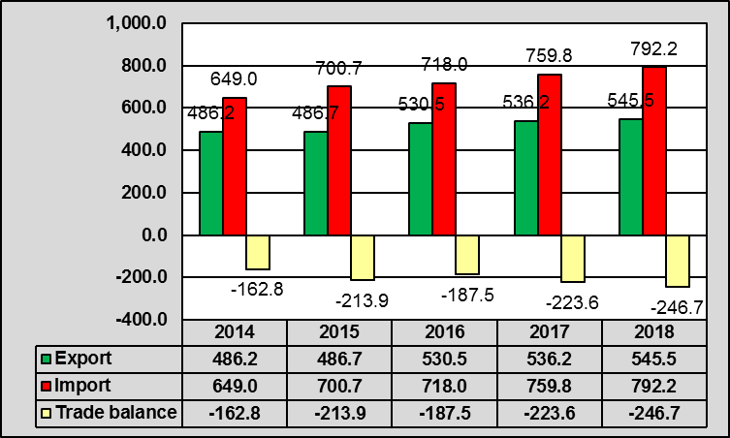
Source: MAFWE
European Union-28 is definitely the most important partner of the Republic of North Macedonia regarding trade with agri-food and fisheries products in 2018. The total value of trade with EU-28 with agri-food and fisheries products in 2018 (export + import) was €670.2 million. The share of agro-food and fishery products export to EU-28 in the total export of these products in 2018 was 50.5%, while the share of import from EU-28 in the total agro-food and fishery products import in 2018 was 49.8%.
The second important partner of the Republic of North Macedonia in 2018 in the trade with agro-food and fishery products were the CEFTA country members, with total value of trade (export + import) of €414.7 million. The share of agro-food and fishery products export to CEFTA country members in the total export of these products in 2018 was 33.9%, while the share of import from CEFTA country members in the total agro-food and fishery products import in 2018 was 28.9%. The most important CEFTA trade partner was Serbia, with a share of 12.7% of the total export of agro-food and fishery products and 23.6% of the total import. It is followed by Bosnia and Herzegovina (with a share of 5.6% in the total export and 3.2% in the total import). Regarding the export, Kosovo is also an important partner with a share of 8.9% of the total export, while the contribution of other CEFTA members countries (Montenegro, Moldova and Albania) is still with lower participation in the trade.
It is worth mentioning that Turkey as a candidate country and an important trade partner of the Republic of North Macedonia takes 0.79% of the total export and 3.4% of the total import of agro-food and fishery products. Regarding the export of agro-food and fishery products, the largest sole non-EU trade partner with a share of 4.9% of the total export was USA, due to significant export of tobacco, while Brazil with a share of 4.5% of the total import was the largest sole non-EU import partner, basically due to significant quantities of frozen poultry and beef and coffee imported in 2018.
  - Changes in national and sectoral policies
Within the framework of the National Strategy for Agriculture and Rural Development 2014-2020 (NSARD 2014-2020), the following goals and measures of the policies for development of agriculture and rural areas have been highlighted:
- Strengthening the competitiveness of Macedonian agriculture in the integrated regional markets of the European Union and South-East Europe through measures to increase the efficiency of agricultural production, processing and sales.
- Improving the incomes of agricultural holdings.
- Enabling consumers to have access to safe, healthy food.
- Optimizing the utilization of limited land, forest and water resources in a way that does not adversely affect the environment.
- Building sustainable rural communities through integrated rural development.
- Build appropriate, efficient public and private institutions for implementation of agricultural policy and rural development.
Achieving the vision and the stated strategic goals for the development of the sector will be realized through the measures and instruments of the following policies in the field of agriculture: agriculture and rural development policy, agricultural support policies and support for rural development policy.
After setting the financial support, social and tax benefits and credit policies for farmers, fully utilizing the development potential of the sector, increasing its competitiveness and, to a large extent, the development of rural areas, NSARD 2014-2020 in the period ahead will focus on tackling structural problems, small and fragmented land plots, insufficient technical and technological equipment resulting from the long disinvestment period, inadequate grade and racial production structure and the poor age and gender structure of the rural population.
  - National support schemes
More important tasks in the field of agriculture policy include the following: directing agricultural subsidies to profitable and market-oriented agricultural holdings; transparency of the budget funds from the national Programme for rural development; consolidation and enlargement of agricultural land; horizontal integration of the entities in the agricultural sector and establishment of cooperatives.

Table 6: Amounts of support (in €) by the Programme for direct payments
Year | 2012 | 2013 | 2014 | 2015 | 2016 | 2017 | 2018
Total | 112,715,447 | 111,959,350 | 101,788,297 | 101,788,618 | 102,764,228 | 99,477,350 | 100,983,740
Source: MAFWE, IPARD Agency
Rural development measures accompany and complement direct support measures (market policies and support for income from agricultural activity) and build on existing support for rural development provided through annual rural development programs.
Taking into account the analysis of the situation in the agriculture and the sectoral development potentials, as well as the specific needs for rural development, the measures for rural development policy implementation are prioritized in increasing the competitiveness of the agricultural sector and strengthening the economic and social position of the rural areas by increasing the agricultural holdings incomes, increasing the employment possibility of the rural population outside the agricultural sector. Special attention is given to the introduction of measures for sustainable management and utilization of natural resources, protection of biodiversity and the environment.
Table 7: Amounts of support (in €) by the Programme for rural development
Year | 2012 | 2013 | 2014 | 2015 | 2016 | 2017 | 2018
Total | 11,381,106 | 17,186,992 | 31,229,268 | 31,400,000 | 29,356,016 | 32,906,390 | 32,295,935
Source: MAFWE, IPARD Agency

- Assessment of the progress in the implementation of objectives, priorities, measures and group of investments

  - Summary of the strategic framework of the IPARD Programme 2014-2020
The IPARD Programme for the period 2014-2020 supports the beneficiaries in adopting and implementing the political, institutional, legal, administrative, social and economic reforms in order to comply with the Union's values and to progressively align to the Union's rules, standards, policies and practices, with a view to Union membership.
The specific objectives set out in Article 2 of Regulation (EU) No 231/2014 should be to the extent possible addressed by all policy areas. This means that agriculture and rural development policy area will contribute to the following specific objectives:
- Support for political reforms;
- Support for economic, social and territorial development, with a view to a smart, sustainable and inclusive growth;
- Strengthening of the ability of the beneficiary countries at all levels to fulfil the obligations stemming from Union membership by supporting progressive alignment with, and adoption, implementation and enforcement of the Union acquis, including preparation for management of Union Structural Funds, the Cohesion Fund and the European Agricultural Fund for Rural Development;
- Strengthening regional integration and territorial cooperation involving the beneficiaries listed in Annex I, Member States and, where appropriate, third countries within the scope of Regulation (EU) No 232/2014 of the European Parliament and of the Council.
The above-mentioned IPA II objectives largely coincide with the main strategic objectives and specific objectives according to NSARD 2014-2020 (section 6.1.1 of this Programme), namely the objectives for enhancing farm viability and competitiveness of all types of agriculture and food-processing, agro-environmental objectives for restoring, preserving and enhancing ecosystems dependent on agriculture and forestry, improving socio-economic development in rural areas and human potential.
Table 8: Budget of EU Contribution by measure 2014-2020, in €
Measures | EU contribution  2014-2020
Investments in physical assets of agricultural holdings | 21,800,000 | 36%
Investments in physical assets concerning processing and marketing of agricultural and fishery products | 21,960,000 | 37%
Investments in rural public infrastructure | 9,100,000 | 15%
Farm diversification and business development | 4,740,000 | 8%
Technical assistance | 2,400,000 | 4%
Total | 60,000,000 | 100%
Source: IPARD Programme 2014-2020
  - Analysis on progress in implementation by measure
The implementation of the Programme started with announcement of the first call (01/2017) in April 2017. To meet the needs of the applicants, the final date for submission of applications under this call was extended until 21st of July. Public call 01/2018 announced in November 2018 was for submission of applications under measure 3. Public call 02/2018 opened late in December 2018 for submitting applications only under measure 1.

Table 9: Overview of implementation of IPARD per public calls in €
 | Public call | Applications |  |  |  |  |  | Time for processing
 |  | Submitted |  | Contracted |  | Paid
 |  | No. | EU contribution | No. | EU contribution | No. | EU contribution
1 | 01/2017 | 1,651 | 72,333,821 | 955 | 15,345,355 | 127 | 1,002,784 | 14 months
2 | 01/2018 | 65 | 15,306,611 | / | / | / | / | /
3 | 02/2018 | 1,099 | 18,335,969 | / | / | / | / | /
Total |  | 2,815 | 105,976,401 | 955 | 15,345,355 | 127 | 1,002,784 | /
Source: IPARD Agency
The process of processing and approving the applications submitted at the first public call took a lot of time. The public call announced in April 2017 had its first contracts for measure 1 signed after 14 months (June 2018). Delays in the process of approving requests limit the possibility of publishing new public calls. The reasons for this situation are the lack of staff in the IPARD Agency, the extensive procedures for controlling the standards, especially the time needed for checking the price of the offers.
Table 10: Indicators on quality of implementation
Total number of applications submitted | 2,815
Number of signed contracts | 955
Number of paid contracts | 127
Number of cancelled contracts | 6
% of contracted applications (contracted/submitted) | 33
% of cancelation of contracts (cancelled/contracted) | 0.6
% of paid contracts (paid/(contracted – cancelled) | 13
Source: Managing Authority

  - Measure 1 – Investments in physical assets of agricultural holdings
During the reporting period, the number of projects submitted under Measure 1 reached 1,404 (17,959,245 EU contribution). Contracts have been signed with 902 applicants (8,127,123 EU contribution) and 6 of them (17,749 EU contribution) were terminated by the Agency. Payment of contracts reached 116 (452,875 EU contribution).
Table 11: Overview of objectives fulfilment by applications in Measure 1
Measure objectives | Received | Contracted | Paid
Improve the overall performance of the agriculture holdings in the production of primary agricultural products | 642 | 392 | 39
Attract young people in the agriculture activities by improving their life and working conditions, as well as ensuring the hygiene and welfare conditions of the livestock | 490 | 325 | 50
Improve farm labour productivity and efficiency of the agriculture production, as well as the post-harvesting and marketing of agriculture products, aiming at increased competitiveness via investments | 270 | 183 | 26
Promote use of renewable energy at farm level and at processing level, as well as increase the overall energy use from renewable resources at national level | 2 | 2 | 1
Source: Managing Authority
Applications received under the first call were of a lower value. Most of the applications (72%) were below 10,000 € and 26% were in the range from 10,000 – 50,000 €.
Figure 3: Review of applications per value of investments in Measure 1
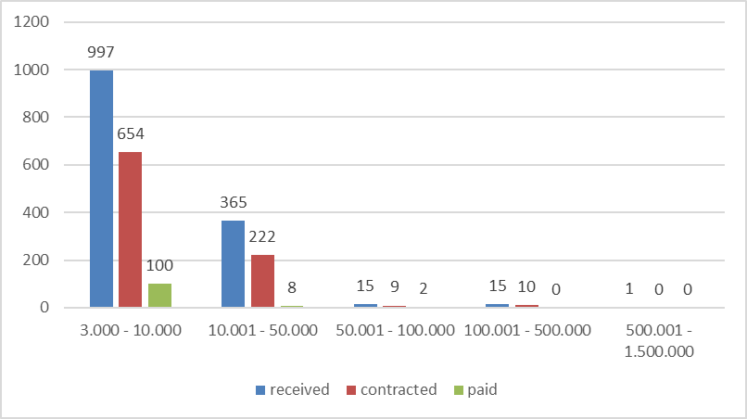
Source: Managing Authority
Having in mind the conditions in the crop production sector, such as: the needs for investments in mechanization modernization, resolved property legal issues, lower value of investments (low level of construction activities) and the overriding problems with the legalization of irrigation wells, most of the applications were submitted in the crop production area.
The real needs for investments in the livestock production sectors relate to the production capacities reconstruction (rebuilding the farms in order to achieve the standards for animal welfare and environmental protection). Investments like this (construction activities) have higher value than those related to equipment procurement and installation, so the lack of such investment activities affected the Programme financial targets implementation.
Table 12: Review of applications per priority sectors in Measure 1
 | Received  (A) | Contracted  (B) | EU part contracted | Paid | EU part paid | % of approval  (B/A)
Cattle | 10 | 2 | 57,430 | 0 | 0 | 20%
Poultry | 4 | 2 | 446,268 | 0 | 0 | 50%
Sheep | 12 | 3 | 17,271 | 0 | 0 | 25%
Pigs | 7 | 3 | 917,611 | 0 | 0 | 43%
Orchards | 444 | 308 | 2,528,272 | 53 | 186,897 | 69%
Vineyards | 155 | 123 | 834,980 | 21 | 40,637 | 79%
Vegetables | 101 | 61 | 381,672 | 5 | 53,922 | 60%
Cereals | 665 | 397 | 2,927,769 | 36 | 168,270 | 60%
On-farm processing | 4 | 1 | 12,790 | 0 | 0 | 25%
Renewable energy | 2 | 2 | 3,150 | 1 | 3.150 | 100%
Source: Managing Authority
Wheat, orchards, grapes and open field vegetables production were types of production most commonly used by the applicants.

Figure 4: Review of applications per production culture in Measure 1
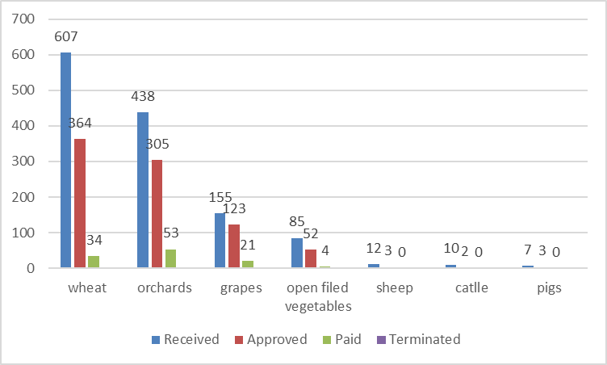
Source: Managing Authority
Regarding the interest for types of investments, investments in tractors and agricultural mechanization, just as in the past, were most attractive for farmers. From the total number of 1,034 applications submitted for tractors, under 688 contracts have been signed (5,413,581 EU funds) and 42 paid have been paid (181,010 EU funds). According to IPARD Programme (Measure 1, Indicative budget), the distribution of the public funds for agriculture mechanization – tractors including their equipment (excluding attachments) shall not exceed 20% of the total available financial budget for this measure (5,893,333.4) for the whole period of the Programme implementation. In this regard, the Public Call 02/2018 did not include tractors as an eligible expense.
Applicants have not shown interest for investing in: environmental protection equipment, specialized agricultural transport trailers and vehicles, irrigation systems, construction and reconstruction of immovable property for agriculture production, processing, post harvesting and direct marketing and development of holdings infrastructure.
Figure 5: Review of applications per type of investment in Measure 1
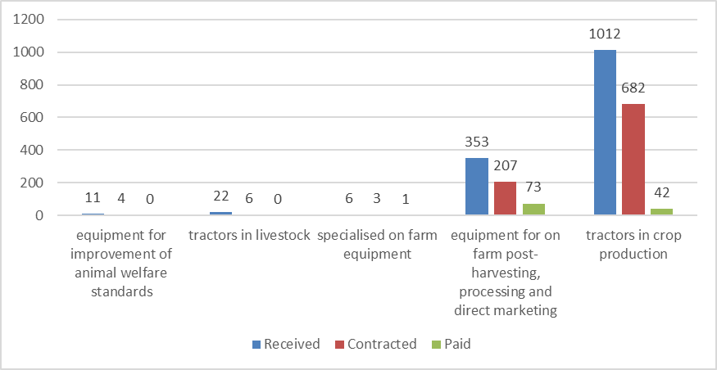
Source: Managing Authority

  - Measure 3 – Investments in physical assets concerning processing and marketing of agricultural and fishery products
During the reporting period, the number of projects submitted under Measure 3 reached 57 (13,027,752 EU contribution). Contracts have been signed with 30 applicants (4,942,889 EU contribution). The payment under contracts reached 8 (546,072 EU contribution).
Table 13: Overview of objectives fulfilment by applications in Measure 3
Measure objectives | Received | Contracted | Paid
Upgrade to the Community Standards as regards environmental protection, public health (food safety and quality of products), animal and plant health, animal welfare and occupational safety | 1 | 1 | 0
Improve the overall performance in the processing and marketing of primary agricultural products | 13 | 6 | 0
Facilitate competition in the internal market by the introduction of new technologies and innovation | 6 | 3 | 1
Promote environmentally sound production practices (reduction of water losses, decreasing the pollution of the environment, and/or elimination of by-products or of wastes) | 3 | 2 | 0
Improve the utilization of processing capacities in terms of efficiency and production technology improvements, as well as marketing activities, at the same time promoting innovations, and aiming at full alignment to the EU food safety standards | 34 | 18 | 7
Source: Managing Authority
The application received under the first call had higher value. Most of the applications (42%) were in the range between 100,000 and 500,000€, 23% were in the range from 10,000 – 50,000€ and 11% were with a value from 50,000 to 100,000 €.
Figure 6: Review of applications per value of investments in Measure 3
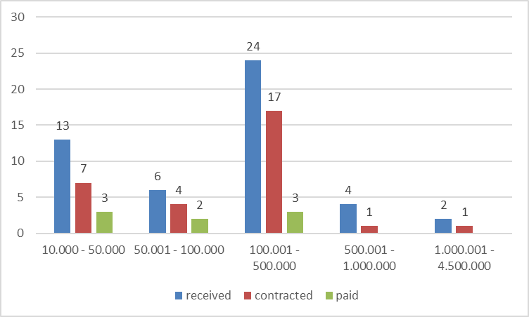
Source: Managing Authority
The interest for use of IPARD Programme funds is highest in the meat and meat products priority sector and fruit and vegetables processing. The fruit and vegetable processing and wine sector are export-oriented, with high level of liquidity of companies and investments needs in equipment for technological process modernization or new production lines introduction.

Table 14: Review of applications per priority sectors in Measure 3
 | Received  (A) | Contracted  (B) | EU part contracted | Paid | EU part paid | % of approval  (B/A)
Milk collection centers | 9 | 5 | 303,880 | 2 | 66,425 | 56%
Meat products | 12 | 8 | 2,328,524 | 3 | 95,783 | 67%
F&V collection centers | 21 | 10 | 1,727,013 | 3 | 383,864 | 48%
Cereals milling | 5 | 2 | 75,879 | 0 | 0 | 40%
Oils and fats | 2 | 1 | 9,619 | 0 | 0 | 50%
Wineries | 8 | 4 | 497,974 | 0 | 0 | 50%
Source: Managing Authority
Regarding the interest for types of investments, investments in equipment for production technology modernization was most wanted for the applicants (especially in F&V processing-11 applications, 5 contracts), followed by construction/reconstruction of operational facilities (especially in F&V collection centers – 10 applications, 5 contracts). In addition, 2 green-field investments have been submitted and there was 1 signed contract (meat processing –poultry).
Applicants have not shown interest for investing in: waste and wastewater management, transport tanks, trailers and specialized vehicles for transport of raw materials, equipment for improvement of animal welfare standards and investments in development of holdings infrastructure.
Figure 7: Review of applications per type of investment in Measure 3
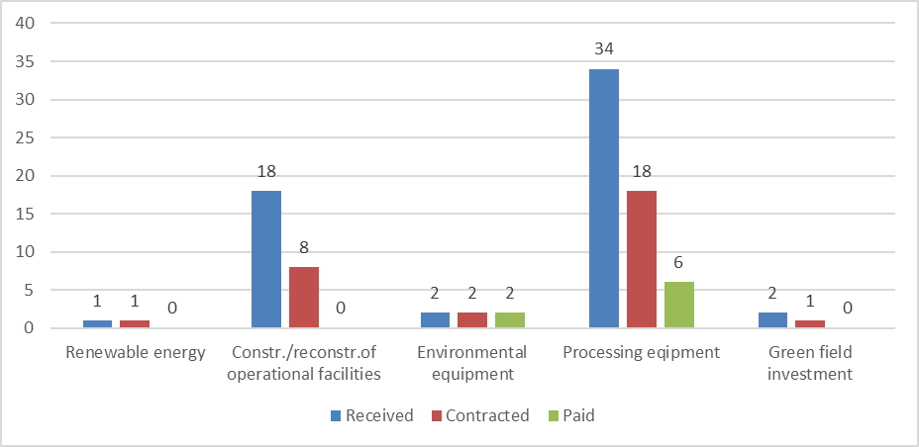
Source: Managing Authority
  - Measure 7 – Farm diversification and business development
Contracting under this measure was delayed due to the great number and value of applications submitted. The first call had 187 applications (41,342,988 € EU contribution) submitted for this measure. The first 20 contracts under Measure 7 were signed early in 2019 (2,271,506 EU contribution).
Table 15: Overview of objectives fulfilment by applications in Measure 7
Measure objectives | Received | Contracted | Paid
Increased economic activities in the rural areas | 4
Creation of employment opportunities for rural population | 47
Enhance or provide additional mainstream services for the rural economy | 5
Provide openings for future economic development, including tourism and craft activities | 21
Support development of existing and new rural businesses for economic development and employment; to develop rural tourism potential | 33
Develop physical infrastructure, upgrade village spaces and increased provision of services and rural accommodation, for tourism and business development in rural areas and improved living conditions in rural areas | 77
Source: Managing Authority
Applications submitted under this measure vary in value of investment. More than half of the submitted applications are in the range of 10,000-50,000€ (27%) and 100,000-500,000€ (27%).
Figure 8: Review of applications per value of investments in Measure 7
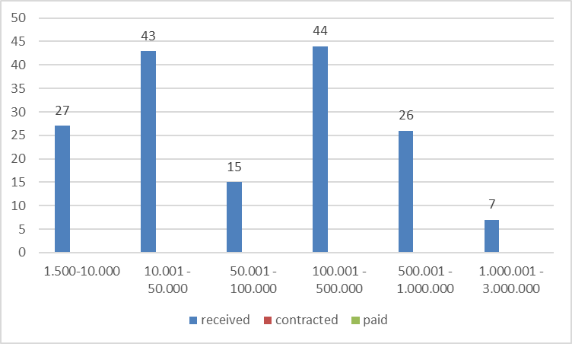
Source: Managing Authority
The interest for use of IPARD Programme funds is highest in the production and sale of renewable energy sector (39 applications for solar, wind, water, geothermal energy), alternative agriculture production (20 applications for cultivation of herbs, seeds, and other spices and aromatic crops), non-food products (33 applications in wood processing) and rural tourism (17 applications in accommodation, 13 application in rural museums).
Table 16: Review of applications per priority sectors in Measure 7
 | Received  (A) | Contracted  (B) | EU part contracted | % of approval  (B/A)
Alternative agriculture production | 39 | 10 | 268,650 | 26%
Manufacture of food products and beverages | 21 | 1 | 20,549 | 5%
Manufacturing of non-food products | 33 | 4 | 502,247 | 12%
Development of crafts activities | 5 | 0 | 0 | 0%
Provision of services to agriculture | 4 | 1 | 9,055 | 25%
Development of services for the rural population | 8 | 1 | 487,158 | 13%
Promotion of Rural Tourism | 32 | 3 | 983,847 | 9%
Production and sale of renewable energy | 45 | 0 | 0 | 0%
Source: Managing Authority
Applicants have not shown interest for investing in: specialized transport tanks and trailers and purchase of perennial trees and plants.
Figure 9: Review of applications per type of investment in Measure 7
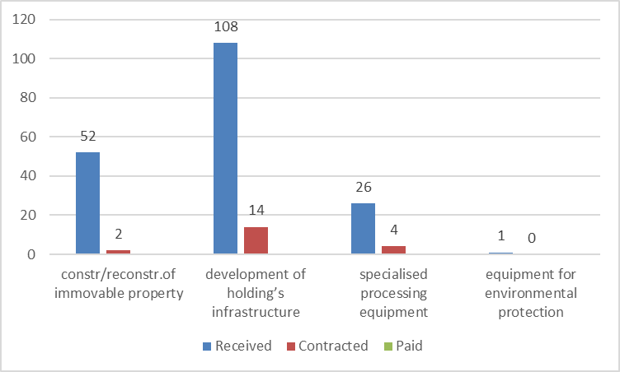
Source: Managing Authority

  - Geographical analysis of IPARD Programme implementation
The data for the geographical implementation of the IPARD Programme and the support to the regional development of the Republic of North Macedonia are presented in this report by statistical regions (NUTS 3) and municipalities.
Most of the total submitted applications come from the regions of Pelagonija (721), Vardar (348), Southeast (150) and East (104). Pelagonija also has the biggest number of contracts (468), followed by Vardar (207), Southeast (68) and Northeast (45).
Figure 10: Review of the applications by statistical regions
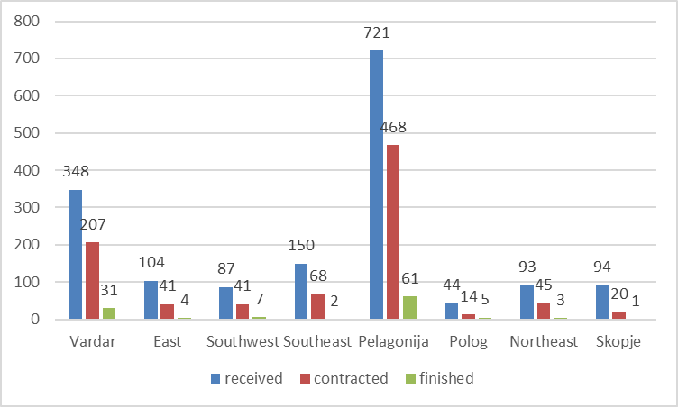
Source: Managing Authority
Crop production (cereals, orchards and vineyards) are predominant agricultural production in the Pelagonija and the Vardar regions. Most of the applications in these regions are for less expensive investments (tractors and small pieces of agricultural mechanization).
Figure 11: Review of the total public expenditure by statistical regions
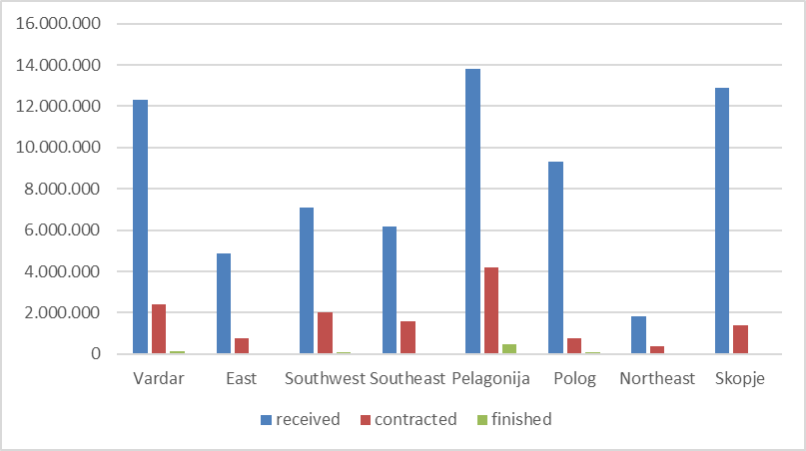
Source: Managing Authority

Table 17: Review of applications per Municipalities
Municipality | No. of applications |  |  | Total public expenditure in EUR
 | received | contracted | paid | received | contracted | paid
Resen | 213 | 166 | 30 | 2,549,515 | 1,348,695 | 207,510
Mogila | 124 | 89 | 14 | 1,422,626 | 562,492 | 62,657
Bitola | 112 | 72 | 4 | 1,981,335 | 887,787 | 19,470
Prilep | 84 | 41 | 5 | 868,771 | 349,461 | 143,447
Negotino | 74 | 48 | 8 | 2,618,895 | 292,525 | 15,748
Novaci | 53 | 38 | 2 | 3,122,449 | 242,380 | 6,759
Kavadarci | 51 | 39 | 9 | 2,827,988 | 178,317 | 16,378
Dolneni | 48 | 26 | 3 | 878,005 | 533,644 | 21,878
Veles | 48 | 23 | 2 | 1,719,844 | 372,523 | 5,842
Kumanovo | 47 | 25 | 2 | 1,230,098 | 248,292 | 7,109
Rosoman | 42 | 29 | 7 | 558,706 | 322,759 | 14,922
Krivogastani | 38 | 20 | 1 | 327,507 | 121,945 | 1,277
Sveti Nikole | 36 | 21 | 2 | 692,622 | 181,612 | 50,715
Debarca | 35 | 18 | 3 | 1,552,488 | 137,292 | 13,183
Caska | 33 | 17 | 2 | 270939 | 110,235 | 5,171
Lozovo | 23 | 13 | 1 | 1,212,163 | 754,053 | 5,657
Source: Managing Authority

- Actions undertaken for improvement of quality and efficiency of IPARD implementation

  - Activities undertaken by the Managing Authority
Considering that in the previous period various activities were undertaken to overcome the problems and improve the implementation of the Programme, recent activities of the Managing Authority were directed towards strengthening the human capacities and improving the Programme aspects of implementation at the request of the beneficiaries and the Agency. In order to strengthen human capacities in 2018, several employees were transferred in the Managing Authority from other MAFWE Departments, so the total number of employees in the Managing Authority reached 16. The Managing Authority was strengthened with one Advisor for Monitoring, one Head of Unit for Programming and two Advisors for Procurement. Also, the Managing Authority's employees deployed in other MAFWE Departments were permanently transferred to the Departments in which they worked.
The first IPARD 2014-2020 Programme modification has been proposed in order to broaden and clarify the opportunities for the potential IPARD II recipients. Most of the proposed modifications are based on the experience of implementing the first Public call of IPARD II in order to facilitate easier implementation process. The experience from the first public call has shown that many of the submitted applications were incomplete, which prolonged the approval procedure. Therefore, some changes in the rules for the mandatory documents to be submitted together with the Application are introduced within this modification.
In addition, modification is proposed to investments related to establishing new irrigation system as eligible investment under the measure “Investment in Physical Assets of Agricultural Holdings”. As a result, since implementing the first public call, some changes for eligible investments in the renewable energy sector under the measure “Farm Diversification and Business Development” are included. Consequently, due to the interest for investments under the measure “Farm Diversification and Business Development” that has exceeded the initially planned funds, changes in the financial allocations are proposed. In addition, few modifications in the eligibility requirements and selection criteria are proposed. Furthermore, modifications are proposed to improve the text of the Programme correcting the technical mistakes and errors.
The change in the list of eligible expenditures for Measure (1) “Investments in Physical Assets on Agricultural Holdings” involves the introduction of frost protection equipment which was proposed at the request of potential IPARD applicants. In addition to this, clarification of the costs eligibility for electricity supply, irrigation, drainage, boreholes, wells, pumps etc. is included.
The change in the list of eligible costs for Measures (3) and (7) follows the approved Programme modification on the production of energy from renewable sources. Also, a change in the list of eligible expenditures for the measure “Investments in Rural Public Infrastructure” was carried out on the basis of findings and recommendation from the conducted audit.

  - Activities undertaken by NAO and NF

The system for indirect implementation of the IPARD Programme 2014-2020 (Measures 1, 3, 7 and 9) was entrusted with the signature and entrance into force of the Financial Agreement for IPARD 2014-2020 in June 2017.
In 2018, improvements of the IPARD Agency working procedures were made, on the bases of:
- experience in the processing of the first public call under IPARD II;
- further recommendations by DG AGRI, on the submitted working procedures;
- having in mind the weaknesses identified in the conformity/financial clearance process under IPARD I and findings from AA.
Modifications of the IPARD Agency Manual of Procedures are approved by NAO as non-significant and entered into force as of the approval of NAO. The main changes concerned streamlining the controls for detecting artificial split of offers due to circumventing the rule of origin (initiated by DG AGRI), improvement of the controls over the data entered in the RPDB, streamlining the text of the Manual for regular market research which is to be performed for the most frequently used items and to be initiated for the expired items as soon as an information for publishing a new public call is received in URPDB.
The other changes that are approved are more of a technical nature and refer to the need for corrections in the manuals and alignment with the recommendations issued by auditors in the Compliance Assessment process for the accreditation of the Rural Infrastructure measure, as well as a change concerning the project approval phase where the time for submitting additional documents by applicants is reduced from 15 (+10 additional days at request of applicants) to 8 days.
In addition, a significant change was proposed in the National Fund working arrangements, in particular in the Accounting System. The proposed working arrangements changes have been assessed by NAO support office and approved by NAO. Having in mind that the changes are significant, they were submitted to DG AGRI for approval in June 2018. Pursuant to the provisions of the Sectoral Agreement, the proposed changes will be implemented after approval by the DG Agri. The need of changes to the applicable National Fund working arrangements arose from the recommendations for improving the accounting system, given by the TWL Project “Strengthening the Capacities of National Authorities for Sound & Efficient Management of EU Funds, as well as in view of New EU Regulation for 2014-2020 Financial Perspective”, as well as the lessons learned from practical implementation. The main reason for modifying the procedures is the recommendation for amendments regarding the recognition of revenues and expense given by the TwL experts. The change is still not approved by the DG AGRI.
The activities undertaken by the IPARD Structures for improving the functioning of the indirect management system are presented in the following part.
Verification Visit
The NAO support office within the 2018 Annual Plan for Verification Visits planned one verification visit concerning IPARD I Programme (ex post checks regarding projects’ sustainability under IPARD I programme), as well as two verification visits over the project approval process and payment process within the IPARD Agency concerning implementation of IPARD II Programme.
In the period June-September 2018 concerning the IPARD I programing period there was a verification visit on site to check the projects’ sustainability for assuring the legality and regularity of paid projects transactions. The second and third verification visit over the project approval process and payment process are finalized as well. The goal of these two verification visits was to supervise the management and control systems, to check the control of the eligible applications for concluding contracts and to check controls concerning legality and regularity of the transactions for the paid projects from the same public call. The total number of projects checked (for Measure 1 and 3) during these verification visits was 9 projects, out of which 6 projects in the project approval process and 3 projects in the payment phase. The total amount of 653,904.33 EUR is checked out of a contracted amount of 17,563,187.45 EUR, representing 3.7% of the total contracted amount and an amount of 67,631.17 EUR is checked out of 449,689.61 EUR paid, representing around 15% of the total disbursed amount up to the preparation of the analysis.
With the 2019 Annual Plan for Verification Visits, verification visits are planned over the project approval process under Measure 7 from Public Call 01/2017 (check on specific control points) and Administrative check on project level concerning implementation of Measure 9 – Technical Assistance.
Monitoring the implementation of the audit recommendations
(a) Internal Audit
The IPARD Managing and Operating structures were subject to internal audit during 2018 by the internal audit departments/units established in each institution.
Management Structure
The 2019 Annual Audit Plan of the Department for Internal Audit within the Ministry of Finance foresees one audit mission within NAO/MS over the system of internal controls of the process of controlling the correctness of the requests for funds and certification of expenditure to the EC.
IPARD Agency
The 2019 Annual Audit Plan in IPARD Agency is adopted. According to the plan, 10 audit missions are planned, out of which 5 audits over processes concerning IPARD and one planned consulting engagement concerning activities related to entrustment of new measures – Measure 5 LEADER and Measure 10 Advisory Services from IPARD Programme 2014-2020.
Managing Authority
The 2019 Annual Audit Plan of the Ministry of Agriculture, Forestry and Water Economy foresees audit mission over the effectiveness of implemented and ongoing projects within the IPA structure in the MAFWE.
(b) Audit Authority Reports
The Audit Authority for IPA during 2018 issued the following Final Audit Reports:
- Final Audit Report for the 2018 system audit in NAO/MS for implementation of IPARD II Programme – Policy area 4 – Agriculture and Rural Development as of 4th of April 2018;
- Final Audit Report for the 2018 system audit in MA for the programmes financed from IPA II – Policy area 4 – Agriculture and Rural Development as of 4th of April 2018;
- Final Audit Report for the 2018 system audit in AFSARD for implementation of IPARD II Programme – Policy area 4 – Agriculture and Rural Development as of 4th of April 2018;
- Final Audit Report for the Audit of Accounts and Statement of Expenditure for 2017 for IPARD I and IPARD II as of 27th of April 2018
- Final Audit Report for the audit of operations.

For the year 2018 the NAO received the Annual Audit Report and Annual Audit Opinion for 2018 from the Audit Authority.
With the Annual Audit Opinion auditors expressed an unqualified opinion regarding the reliability of the annual financial reports or statements/annual accounts. The auditors expressed unqualified opinion with emphasis on the matter of legality and regularity of expenditures and the functioning of the management and control systems, with attention regarding to: insufficient staff in the IPARD Agency, no retention policy, lack of professional trainings, unharmonized Law on Establishing the IPARD Agency, lack of supervision in the process of payment authorization and wrongly calculated reference price.
The table below presents findings from the 2018 Annual Audit Report for implementation of IPARD II Programme:

 | Major | Intermediate | Minor | Total
NAO/MS | / | 2 | / | 2
MA | 2 | 6 | / | 8
IPARD Agency | 6 | 4 | 3 | 13
Total: |  |  |  | 23

Regarding the open findings from the AA reports, NAO in coordination with the operating structure drafted an Action Plan with deadlines and responsibilities for implementation of recommendations and overcoming the findings.
NAO continuously monitors the implementation of the actions agreed for overcoming the findings. On quarterly basis, the IPARD Agency and the Managing Authority submit to NAO Table for implementation of audit recommendation, where the latest status of undertaken activities is given. The NAO support structures perform analysis on the dynamics of activities implementation and inform NAO regarding the status of implementation.

Monitoring of the Administrative Capacities of the Operating Structure

Management Structure
According to the Workload Analysis of the Management Structure for 2018, it was identified that the optimal number of employees for 2018 is 21 (including NAO). At the beginning of 2018 the number of employees in MS was 17 (seventeen), including NAO.
During 2018, one employee was engaged with temporary employment contract in the IPA Funds Management Department. The contract expired in July 2018 and the employee left the MS. In addition, the other temporary contract for the Junior Associate that was engaged in MS in December 2017 was renewed and the person was engaged until December 2019 in MS.
Therefore, the number of employees in the Management Structure is 17 (seventeen), including NAO, as of 31.12.2018.
According to the situation at the end of 2018, the working posts occupancy rate in the IPA Funds Management Department is 81%, having in mind that the 2018 WLA shows a need for optimal number of 21 employees.
In addition, concerning retention, internal announcement 01/2018 for promotion of 5 administrative officers – junior associates from both units within the MS was published in October 2018 and by December 2018, 3 civil servants were promoted from junior associates to advisors and one into associate.
According to the 2019 WLA the optimal number of employees in the Management Structure is 20 (including NAO).

IPARD Agency
According to the 2018 Workload Analysis (WLA), the optimal number of employees needed in the IPARD Agency for implementation of the accredited measures, as well as the Rural Infrastructure measure is 170 employees. At the beginning of 2018, the IPARD Agency numbered 87 employees designated to work on IPARD related issues.
As already informed, the strengthening of the Agency’s human resources capacity was considered a priority, and strong commitment for realizing the necessary employments can be noted during 2018.
Namely, the IPARD Agency employments procedure, according to the Government conclusions, was decided to be carried out in the following three phases:
First phase – 28 new employments;
Second phase – 20 new employments and
Third phase – 20 new employments.
The first phase was completed in April 2018 and starting from the first week of May, the selected candidates were hired in the Agency on temporary basis until 31.12.2018. Out of the aforementioned 28 people, 22 work in the IPARD structure of the Agency, and 6 people are indirectly involved in the implementation of the IPARD Program 2014-2020. Having in mind that these employees are on a temporary basis contract, their contracts were extended until 30th of April, 2019.
In addition, during 2018, 1 (one) employee (junior associate) left his position in the Agency and 1 (one) employee was transferred to work from non-IPARD to IPARD related work.

Accordingly, at the end of 2018 (cut-off date 31.12.2018) the number of employees in the IPARD Agency was 109 (one hundred and nine) employees designated to work on IPARD related issues.
The implementation of the second phase started with public vacancy announcement at the end of October 2018. The second phase was completed in January 2019 and from 11.01.2019 the selected candidates were hired in Agency as permanent employees. Within this procedure, of the 20 new announced employments 12 employees were hired, out of which 11 were designated to work on IPARD, and 1 employee is indirectly involved in the IPARD Programme 2014-2020 implementation.
According to the 2019 Workload Analysis (WLA), IPARD Agency has set optimal level of staff of 150 employees, including 22 employees for the measure Investments in Rural Infrastructure, which is not yet accredited/entrusted.
The IPARD Agency republished the public vacancy for employment of 8 other administrative servants and 4 promotions of current staff on 03.01.2019. The procedure is still ongoing.
In parallel, having in mind the retention and motivation policy, a procedure for promotion of 28 existing administrative civil servants started on 17.10.2018 with 20 announced internal vacancies, and public vacancies for 8 employees. These procedures for promotion were completed in January 2019. Within these procedures, a total of 21 civil servants were promoted in the Agency, of which 15 civil servants are involved in the IPARD structure of the Agency.
A third phase is also planned – procedure for employment of additional 20 new administrative civil servants, i.e. the Vacancy call should be published during the second quarter of 2019 due to the announced presidential elections.
With the realization of the 2019 recruitment plan as stated above, the IPARD Agency shall reach an optimal number of employees as per the 2019 WLA.

Managing Authority
According to the 2018 Workload Analysis (WLA), the optimal number of employees needed in the Managing Authority was 19. At the beginning of 2018, MA counted 13 employees including HoMA. During 2018, 8 (eight) new employees were engaged within MA, while 4 (four) employees left/were reallocated from their working post in MA.
In addition, on 30.11.2018 the Minister of Agriculture, Forestry and Water Economy adopted two decisions for authorization to act in the position of Head of Unit for IPARD Monitoring and Reporting and in the position Head of Unit for TA.
According to the 2019 Workload Analysis (WLA), the Managing Authority has set an optimal level of staff of 19 employees for 2019, and an optimum of 20 for 2020.

IPARD Structure capacities
The table below presents the data regarding the human capacities in the IPARD structure for the year 2018:

Institution | Number of staff on 31.12.2017 | Number of staff needed as per WLA 2018 | Realized new recruitments 2018 | Promotion of the staff 2018 | Left the position 2018 | Number of staff 31.12.2018 | Occupancy  rate | Turnover rate
NAO/NF | 17 | 21 | 1 | 4 | 1 | 17 | 81% | 5.9%
IPARD Agency | 87 | 170 | 23 | 15 | 1 | 109 | 64% | 1.2%
Managing Authority | 13 | 19 | 8 | / | 4 | 17 | 90% | 30.8%
Total | 117 | 210 | 32 | 19 | 6 | 143 | 68% | 5.1%
Accreditation of new measures within the IPARD Programme frame
The preparatory activities for accreditation of the measure Rural Infrastructure began in 2015/2016. After the compliance assessment report (January 2018) and the DG AGRI observations on the submitted draft working arrangements for the rural infrastructure implementation (June 2018), the activities for completion of the accreditation package incorporating the observations from both reports were undertaken.
The Request for entrusting with budget implementation tasks for the measure Rural Public Infrastructure from the IPARD Programme 2014-2020 was submitted to EC on 13th November 2018.
With letter dated 3rd of April 2019, DG AGRI submitted initial observations and recommendations concerning the submitted package for EBIT request. The main observations were related to the HR capacities, the Law on AFSARD and the IPARD Agency procedural arrangements.
After receiving the observations and recommendations by DG AGRI, national authorities held a coordinative meeting with the Minister of Agriculture, and for the purpose of a more efficient implementation of the process of entrustment and current implementation of the Programme, agreed to submit the revised package by mid-September 2019.
The current status of the main issues presented in the DG AGRI letter is the following:
1. The amendments of the Law on the Establishment of the Agency, although planned to be adopted in March 2019, due to the presidential elections that are ongoing, is postponed for May 2019.
2. Regarding the human resources capacities a detailed elaboration is given under point 3 – IPARD Agency.
3. Regarding the observations on the procedures, initial assessment on the EC recommendations was performed and appropriate activities shall be duly implemented in parallel with the capacity building activities.
Implementation of the IPARD Programme and Absorption of IPA Funds
The first public call under IPARD Programme 2014-2020 was closed in July 2017. Under this public call 1,648 applications were received. The contracting phase from the first public call under the IPARD Programme 2014-2020 is ongoing and until 31.03.2019 901 contracts were signed under Measure 1 in the amount of 10,719,321.00 ЕUR (IPA + NKF), 31 contracts were signed under Measure 3 in the amount of 6,621,696.00 ЕUR (IPA + NKF) and under Measure 7 there were 22 projects in the amount of 5,866,064.75 ЕUR (IPA + NKF).
During December 2018 two public calls were published for Measure 1 and Measure 3. Under these public calls 1,164 applications were received (1099 under Measure 1 and 65 under Measure 3).
For Measure 9 (Technical Assistance) there are 11 applications submitted to the IPARD Agency, out of which contracts were signed for 9 projects in the amount of 149,000.02 EUR and under 3 contracts an amount of 4,512.35 ЕUR (IPA + NKF) was paid.

Financial management
Regarding the financial management of Community funds, the activities were regularly performed according to the regulations and adopted procedures. Untill 23rd April 2019 the executed payments for Community contribution amounted to 1,675,412.01 EUR. Declarations of Expenditures that serve as Payment Applications were submitted for each quarter of 2018, as well as for the first quarter of 2019 in line with set deadlines. The declared amount of Community contribution is 1,395,735.77 EUR. The payment applications were regularly sent through SFC 2014 by the National Fund. All transactions made on the NF bank accounts were properly recorded in the NF accounting system.
Calculation of De-commitment of funds
When calculating the potential risk of de-commitment, the following inputs/ assumptions have been taken into consideration:
- Total IPA allocations 2014-2016 are 15,000,000.00 EUR;
- Received pre-financing is 6,300,000.00 EUR;
- Amount planned to be paid in 2019 is 11,250,000.00 EUR;
Taking into consideration the above stated inputs, there is no potential risk of de-commitment of funds at the end of 2019.
V component
Calculation of De-commitment Risk According N+4 Rule
No. | Reference | Community Contribution in €
1. | Financial allocations | 15,000,000.00
2. | Received pre-financing | 6,300,000.00
3. | Paid amount until 23.04.2019 | 1,675,412.01
4. | Amount planned to be paid by end of 2019 | 10,577,376.09
5=1-2-3-4 | No Potential De-commitment of funds at the end of 2019

However, the de-commitment may occur taking into consideration that 7 mill EUR should be paid by the end of the year, out of which 3.8 mill EUR are planned to be realized in Q4 of 2019.
  - Activities undertaken by the IPARD Agency
4.3.1 Progress in collecting follow-up data
In compliance with the responsibilities undertaken from the Implementing Agreement between the MA and the IPARD Agency, the IPARD Agency reported on regular basis about the execution of IPARD Programme.
The exchange of data is done thought the Monitoring and Evaluation Tables for IPARD Programme, as well as with other prepared reports upon request of MA, which contained data included in the Tables, but were relevant for the execution of the Programme.
In 2018, the IPARD Agency with the defined deadline and on a regular basis delivered to the MA the monitoring tables for implementation of the IPARD Programme which include information on physical and financial indicators, reports from the performed controls, identified irregularities and additional requests for reports, defined in the Implementing Agreement.
The data collection and the reports preparation was maintained manually in excel format.
During 2018, the IPARD Agency recorded all transactions parallel in excel and the SAP software and in manual form, as well. As soon as we are convinced that all reports going through SAP are true and accurate, the SAP software will be used as the only accounting tool in the IPARD Agency and all financial indicators will be drawn from the system.
4.3.2 Summary from the Contract follow-up
In terms of implementing the IPARD Program 2014-2020, in 2018 the IPARD Agency signed contracts under 935 applications in the supported amount of 13,076,910 €.
For public call 01/2017 the IPARD Agency signed contracts under 902 applications for Measure 1 in the amount of 8,127,123€ and 30 contract under applications for Measure 3 in the amount of 4,942,889 € and 3 contract for Measure 9 in the amount of 3,836.5 €.
During 2018, the IPARD Agency announced the following public calls for measures under the IPARD Programme:
- on 30.11.2018 the public call for IPARD II for measure 13 “Investments in physical assets concerning processing and marketing of agricultural and fishery products“,
- on 26.12.2018 the public call for IPARD II for measure 11 “Investments in physical assets of agricultural holdings“.
Most of the signed contracts concerned purchase of equipment and machinery, having short term period for investment implementation and therefore, no progress report letters were required from the applicants.
During 2018, the IPARD Agency received 1,651 claims for payment under the published call 01/2017 which were processed or are still being processing in the current year. The IPARD Agency approved 127 claims for payment.
The total approved amount for payment in 2018 was 1,002,786.00 €.
1. Received claims for payment in 2018
- for Measure 1, 1404 claims for payment received
- for measure 3, 57 claims for payment received
- for Measure 7, 187 claims for payment received
- for Measure 9, 3 claims for payment received
2. Approved claims for payment in 2018:
- for Measure 1, 902 claims approved for payment
- for Measure 3, 30 claims approved for payment
- for Measure 7, 0 claims approved for payment
- for Measure 9, 3 claims approved for payment
3. Total approved amount for payment:
- for Measure 1, under 116 claims for payment 452,878 € paid.
- for Measure 3, under 8 claims for payment 546,071 € paid.
- for Measure 7, 0 claims for payment .
- for Measure 9, under 3 claims for payment 3,836.5 € paid.
In total: 1,002,786.00 €.
4.3.3 Critical issues in implementing the IPARD Programme
In 2018, the IPARD Programme 2014-2020 for the new programing period was adopted and AFSARD accordingly made certain changes in the internal procedures and the control lists in view of the proposed modifications. One of the most significant changes for the new programing period is that the Agency will obtain, as much as possible, of the required documentation ex officio, which would enable shortening the application completing procedure i.e. shorten the procedure for approving the applications.
Progress Summary from the Community Financial Support implementation
Regarding the implementation of the IPARD Program 2014-2020, in 2017 AFSARD announced Public Calls for the measures under the IPARD Program. After the administrative check of all applications under Public Calls 01/2017, during 2018, 127 contracts were signed with total amount of the financial support reaching 1,002,786 €. euros.
The human resources capacities and the time frame for applications processing still remain the most critical issues. Since the number of applications received under the public calls is significantly increased, the current staff is challenged to meet the deadlines determined by law for applications processing and payment claims.
In 2018, the Agency encountered problems during the payment claims processing, as well as difficulties in providing the necessary documentation for the beneficiaries.
Specific problem areas include respecting deadlines and stipulations stated in the co-financing contract, providing proof for origin of the materials and the equipment, timely and correct update of the accounting records, etc.
4.3.4 Results from performed on-the-spot controls and identified irregularities
I. During 2018 the IPARD Agency executed administrative controls of all submitted applications. The reasons for application rejection prior to contract signing are as follows:
Completeness:
- the applicant has not submitted a response within 15 days after receiving Notification for completing the application;
- the applicant has submitted a response within 15 days after the receiving Notification for completing the application, but there were some documents missing or the submitted documents were not valid.
Eligibility:
- capital/family connection between the suppliers or between supplier and applicant;
- proportional increase of the prices of submitted offers (inflated offer prices), which indicates that the offers are not issued by independent suppliers;
- proposed investments are not eligible according to the IPARD Programme;
- during the applications’ administrative processing is has been found that the best offer selection was made prior to providing the offers, indicating that the applicant did not respect the procedure for selecting the most suitable supplier, and has first chosen the supplier and then obtained the offers.
During 2018, the Project Approval Sector rejected 502 applications for Measure 11 in total public expenditures of 2,342,916.3€, rejected 25 applications for Measure 13 in total public expenditures of 1,193,028 € and rejected 189 applications for Measure 31 in total public expenditures of 13,246,903 €.
The reasons for rejecting the received applications amount to not fulfilling the IPARD program criteria.
During 2018 the Payments Authorization received 530 payment claims, of which 127 claims are in the process of payment approval, 8 claims were rejected and 8 contracts were canceled.
Received claims for authorization of payment in 2018
- for Measure 1, 516 claims received for payment authorization
- for Measure 3, 14 claims received for payment authorization
- for Measure 7, 0 claims received for payment authorization
- for Measure 9, 3 claims received for payment authorization
The reasons for claims rejection/contracts cancelation are infringement of contract, undelivered payment claims.
The reasons for issuing Decisions for Funds Recovery include: contract infringement, overpayment, administrative mistake.
II. As regards the on-the-spot controls, the On-the-spot Control Sector carried out a total of:
- 902 on-the-spot controls upon investments under Measure 1
- 27 on-the-spot controls upon investments under Measure 3
- 3 on-the-spot controls upon investments under Measure 7
- 319 on-the-spot controls prior to payment, of which:
- 308 on-the-spot controls upon investments under Measure 1
- 11 on-the-spot controls upon investments under Measure 3
- 157 ex-post on-the-spot controls, of which:
- 149 on-the-spot controls upon investments under Measure 1
- 3 on-the-spot controls upon investments under Measure 3
- 5 on-the-spot controls upon investments under Measure 7
The the On-the-spot Control Sector has carried out 5 on-the-spot controls for establishing hidden works during realization of investment
Two on-the-spot controls after contract signing, but before payment claim is sent under Measure Technical assistance were carried out in 2018.
  - Report on the work of the IPARD Monitoring Committee
Since its inception in January 2016, the IPARD Monitoring Committee has held 4 meetings. The change in the Government has reflected in the change of the Monitoring Committee. A new Decision for establishing a Monitoring Committee was signed by the Minister in October 2017. Consequently, new members were appointed in the Monitoring Committee, so at the moment it comprises of 14 government representatives (4 from MAFWE), 15 representatives of social and economic partners and the Chairperson. The Committee adopted new Rules of Procedure in February 2018.

  - Evaluation of the IPARD Programme
Evaluations shall aim to improve the quality, effectiveness and consistency of the assistance from Union funds and the strategy and implementation of the IPARD II Programme. The IPARD II Programme shall be subject to ex-ante and ex-post and, where considered as appropriate by the Commission, interim evaluations carried out by independent evaluators under the responsibility of the MA.
The evaluations shall assess the implementation of the IPARD II Programme towards the achievement of its objectives and shall examine the degree of utilization of resources, the effectiveness and efficiency of the programming, its socio-economic impact and its impact on the defined objectives and priorities. They shall identify the factors that contributed to the success or failure of the implementation of the IPARD II Programme, including the sustainability of actions and identifications of best practices.
In accordance with the evaluation plan for the IPARD II Programme drawn up by the Managing Authority and approved by the Monitoring Committee, the Managing Authority shall report each year on the results achieved under the evaluation plan to the IPARD II Monitoring Committee.
Responsibilities and coordination
In order to ensure that the monitoring and evaluation system is able to deliver results, a well-designed and robust governance and coordination system is a prerequisite. The Framework and Sectoral Agreements set the legal requirements and define responsible bodies for implementation of the monitoring and evaluation tasks.
The overall responsibility for organizing the evaluation process of the IPARD II Programme lies with the Unit for IPARD Programming and Evaluation, within the IPARD Managing Authority. They are responsible for drawing up an evaluation plan and coordinate its implementation. The Managing Authority is also responsible for communicating each evaluation to the European Commission and for making evaluation reports public. In addition, the Head of the Managing Authority chairs the Evaluation Steering Committee, facilitating cooperation amongst the monitoring and evaluation stakeholders and ensuring capacity building of stakeholders. The MA is also directly involved in collecting and processing monitoring data.
The Monitoring Committee has the responsibility to monitor the implementation of the programme and progress towards its objectives, principally with indicators, and considers and approves the Agriculture Implementation Reports (AIRs) before they sent to the EC.
Evaluation plan 2014 – 2020
The following indicative outline explains the time plan for evaluation activities for the IPARD II Programme:
- 2016 – Identifying Programme-specific evaluation needs, defining Programme-specific evaluation questions and indicators, identifying evaluation data requirements and screening data sources; deciding on the data to be collected for evaluation through the monitoring system from application forms, payment requests and other monitoring tools.
- 2017 – The Managing Authority observes the progress of the Programme and collects beneficiary data via monitoring systems for output, target and complementary result indicators, preparation of the ToR and tendering and contracting procedures for external evaluators/experts.
- 2018 – The external evaluators/experts are contracted to collect additional information/data to fill data and information gaps and to conduct ad hoc evaluations to prepare inputs for the AIR 2018.
- 2019 – The Managing Authority conducts a quality control of evaluation findings and of any other input the evaluator provides; evaluation results discussed in the evaluation steering group and with the Monitoring Committee; regarding the evaluation findings if need be, the MA shall prepare IPARD II Programme modification proposal.
- 2020 – Conducting ad hoc evaluation studies if needed;
- 2021 – The Managing Authority ensures that the necessary resources are available to undertake evaluation tasks until 2024.
- 2022 – Preparation of the ToR and conducting tendering procedure, to ensure that adequate time is given to the external evaluator to conduct a quality ex post evaluation.
- 2023 – All projects contracted under the IPARD 2014–2020 programming period will be finalized, including the collection of monitoring data on beneficiaries for output, target and complementary result indicators. In addition, data on non-beneficiaries is collected, processed and synthesized in line with the selected evaluation methods and reporting requirements, in order to enable the assessment of Programme impacts and achievement towards the EU and rural development objectives in the IPARD ex post evaluation of 2024.
- 2024 – By June 30th 2024 the MA will prepare and submit the standard 2024 AIR (covering the year 2023) and by December 31st 2024 the Ex post evaluation report.
  - The use of Technical Assistance
An Action Plan for the Technical Assistance measure for 2018 (APTA 2018), was adopted by the IPARD Monitoring Committee members through a written procedure. The modification of APTA 2018 was submitted to the IPARD Monitoring Committee members for adoption by written procedure on September 18, 2018. The modification was done for the purpose of organizing two Monitoring Committee meetings (the fourth and the fifth) under one procurement, as well as changing the estimated value of the “EX-post evaluation of the IPARD programme 2007-2013” and changing the tendering procedure from competitive negotiated procedure to simplified procedure (in accordance with the new PRAG from August 2018).
On 17th of May, after the previously selected best rank offer procurement, the organization of the IPARD Monitoring Committee was implemented.
The Managing Authority also began the implementation of the procurement for upgrading and maintaining the existing website. Three offers were received and the best rank offer was selected. The contract for implementation of this activity was signed between the Managing Authority and the selected company, which will upgrade, host and maintain the www.ipard.gov.mk website.
The Managing Authority started implementing project “Publicity Campaign”. In the scope of this project several events have been envisaged (some of them already implemented – one IPARD forum in Strumica in December), materials for Programme publicity have been foreseen for printing (Guidelines for beneficiaries, brochures, banners have already been printed) and promotional videos are to be prepared.
The Managing Authority has also implemented procurement of stationery. The procurement will be implemented according to the procedure for procurements under 2,500€.
The Managing Authority has received the reimbursed funds from the IPARD Agency on its own bank account regarding the previously completed procurement for the implementation of the Monitoring Committee.
On 4th December 2018 an Action Plan for the intended operations under the Technical Assistance measure (APTA) 2019 was approved by the IPARD Monitoring Committee.
Activities under APTA 2019 initiated in 2018 include:
- Procurement of services for ex-post evaluation of the IPARD Programme 2007-2013, currently in the phase of collection of offers.
- Procurement of services for organization of meetings of Monitoring Committee.
- Procurement of services for translation of IPARD Programme 2014-2020.
  - Implementation of the Communication Plan
At the beginning of 2018, and in accordance with the dynamics of planned activities for accreditation of the measure “Investments in rural public infrastructure”, in order to have proper preparation of the local self-government administration for using the funds from the measure, the Managing Authority in cooperation with the Development Centers of the eight planning regions in the Republic of Macedonia, held meetings with the municipal administration from all municipalities. The meetings, besides basic exchange of information regarding the possibilities offered by the measure, were aimed at determining the needs of the units of local self-government, their priorities, as well as determining the municipal capacities for the implementation of the measure.
The annual Action Plan for Publicity and Communication of IPARD II Programme for 2018 was adopted and presented at the third IPARD Monitoring Committee meeting held in May. It included:
- organization of informative days (target 35),
- IPARD forum (target 1),
- workshops (target 2),
- appearance in written and electronic media (target 200),
- annual publication of the list of final beneficiaries,
- preparation and distribution of brochures (target 6,000),
- preparation of posters (target 650),
- preparation and publication of audio and video materials (target 3),
- regular update of IPARD web page.
Due to the large number of applications submitted under public call 01/2017 and the delay in signing the contracts, the following public calls were announced at the end of 2018. This contributed to some of the publicity activities planned for 2018 not to be realized, to be postponed or realized, but with significant reduced intensity.
According to the annual Action Plan for Communication and Publicity for 2018 regarding IPARD Programme 2014-2020, the following activities were realized during 2018:
- the contract with the selected company for upgrading, hosting and maintaining the website www.ipard.gov.mk (for a period of one year) is in the phase of realization and the web site is updated and improved regarding the contract requirements;
- increased communication with the public was recorded through email and the call center (only in July there were 120 calls, due to signing the contracts for tractors);
- in regards to the Public calls there was a significant number (above 126) of press releases and written interviews (daily newspapers and internet portals) and there were 180 calls in the call center of IPARD Agency and 110 visits;
- the Public call 01/2018 for Measure 3 of the IPARD Programme 2014-2020 was published on 30 November 2018 on the website of the IPARD Agency, the website of the IPARD Managing Authority, as well as in the printed media;
- the Public call 02/2018 for Measure 1 of the IPARD Programme 2014-2020 was published on 26 of December 2018 on the website of the IPARD Agency, the website of the IPARD Managing Authority, as well as in the printed media.
Under measure Technical Assistance, in November the Managing Authority signed a contract with 3D Project Studio to provide logistical support for realization of campaign for IPARD Programme publicity. According to the contract the company is obliged to:
- provide logistical support in organizing 70 IPARD informative days, 6 workshops, 3 forums;
- provide ideal solution and produce 3 IPARD videos and 1 radio commercial;
- print publicity materials (application packages, brochures, banners).
The realization of the contract “IPARD publicity campaign” began with a workshop for Measure 3 in Strumica on 26th of December 2018. Printed materials for this measure were produced in one part (a total of 4,456 materials – brochures, application packages, posters, banners). The preparation and printing of materials for Measure 1 was made shortly after the public call 02/2018 was announced.

- Coordination of IPARD funds with national funding, other IPA components, IFI’s and donor support
The coordination between the donor assistance instruments and IPA is based on the integration of the coordination function within the Secretariat for European Affairs under the management of NIPAC. At the same time, NIPAC is appointed by the Government as responsible for coordination of foreign aid.
Concerning IFI’s, NAO also acts as State Advisor in the MoF which coordinates the use of IFI’s funds.
Both the Head of MA and the Director of the IPARD Agency are nominated members of the IPA MC and regularly participate on the joint meetings which are held once a year.

ANNEX 1:
Indicator Tables for Monitoring and Evaluation of the IPARD Programme 2014-2020
Status: 31.12.2018

Available data on agricultural production and economy was for 2015 (except for trade)
Public call for submission of applications only under measure 3
Public call for submission of applications only under measure 1
Value of investments is presented as total eligible expenditure
Value of investments is presented as total eligible expenditure

