
REPUBLIC OF NORTH MACEDONIA
MINISTRY OF AGRICULTURE, FORESTRY AND WATER ECONOMY
IPARD MANAGING AUTHORITY

GENERAL INFORMATION ON PROGRAMME IMPLEMENTATION

(for the period until December 2025)

December 2025

Content:

1. Introduction 3
2. Assessment of the progress in implementation of objectives, measures and investments of the IPARD Programme 2021-2027 4
2.1 Summary of the strategic framework of the IPARD Programme 2021-2027 4
2.2 Analysis of the process of implementation by measure 7
a. Implementation of measure 1 8
b. Implementation of measure 3 9
c. Implementation of measure 7 10

- Introduction
This report is being prepared in order to present the general information on the implementation of the IPARD Programme 2021-2027, its measures, sectors per measure, types of activities and regional/geographical breakdown of the IPARD support.
The data for implementation of the Programme (per priority sector, types of activities) arising from the monitoring tables, are cumulative and refer to the period from the start of the implementation of the Programme until 30th of June 2025. The data on output indicators on number of applications per measure and public calls are from November 2025.
The analysis of the implementation of the Programme is made based on semi-annual data on output indicators, received from the IPARD Agency.
- Assessment of the progress in implementation of objectives, measures and investments of the IPARD Programme 2021-2027
- Summary of the strategic framework of the IPARD Programme 2021-2027
Within the context of the overall IPARD objectives, as well as the objectives of the National Agriculture and Rural Development Strategy 2021-2027 and IPA III Programing Framework and Strategic Response, taking into consideration results of the SWOT analysis and prioritisation made in North Macedonia, the following objectives were selected for the IPARD Programme 2021-2027:
- Enhancing farm viability and competitiveness of agriculture and food processing;
- Restoring, preserving and enhancing ecosystems dependent on agriculture, fishery and forestry;
- Promoting balanced territorial development in rural areas;
- Transfer of knowledge and innovation in agriculture, forestry and rural areas;
- Horizontal and cross-cutting priorities:
- projects promoted by women and young entrepreneurs (between 18 and 40 years of age)
- active agriculture holdings;
- activities benefiting the environment and mitigating climate change effects;
- implementation of innovations and new products;
- development of entrepreneurship and job creation;
- joined initiatives and collective investments;
- diversification of activities in the less economically developed areas (rural areas,
- mountainous areas, near bordering areas and areas within least developed regions);
- rural tourism promotion in areas regarded as cultural heritage, near archaeological sites or natural parks or nature monuments;
- preservation and promotion of traditions and heritage;
- actions strengthening human capital in rural areas and promoting local initiatives;
- actions strengthening the business development skills and abilities
The horizontal and cross-cutting priorities will be applied regardless of these Programme objectives. In practical terms it means that in the Programme these will be reflected in the ranking to be applied during the actual project selection processes per measures where applicable or will be implemented through higher aid intensities.
The achievement of the objectives of the measure is measured by a set of specific indicators defined and targeted for each measure.

Measure indicators |  | Projected target | Achieved results | Achieved in %
Measure 1 | Number of farms and agri-food and fishery processing enterprises  supported by IPARD in modernization | 1.800 | 250 | 13,9
Measure 1 | Total investment on farms and agri-food sector in modernization | 64,8 mill. € | 5,7 mill. € | 8,8
Measure 1 | Number of farms and food and fishery processing enterprises receiving IPARD investment support to progressively align with the EU hygiene and animal welfare standards | 1.000 | / | /
Measure 1 | Number of jobs created | 250 | / | /
Measure 1 | Number of young farmers receiving IPARD support for investment | 800 | 797 | 99,7
Measure 1 | Number of supported producer groups/organizations | 10 | / | /
Measure 1 | Number of farmers participating in supported Producer Groups, Producer Organizations, local markets, short supply chain circuits and quality schemes | 120 | / | /
Measure 1 | Number of collective investments | 15 | / | /
Measure 1 | Number of IPARD recipients with support in investments related to care for the environment or climate change | 1.000 | / | /
Measure 1 | Number of IPARD recipients with support in investments related with manure management | 70 | / | /
Measure 1 | Number of IPARD recipients with support in investments in waste treatment or management | 140 | / | /
Measure 1 | Number of IPARD recipients with support in investments in renewable energy production | 200 | 3 | 1,5
Measure 1 | Number of projects with circular economy-type investments | 10 | / | /
Measure 3 | Number of farms and agri-food processing enterprises supported by IPARD in modernization | 120 | 8 | 6,7
Measure 3 | Total investment on farms and agri-food sector in modernization | 79,4 mill € | 0,7 mill. € | 0,9
Measure 3 | Number of farms and food processing enterprises receiving IPARD investment support to progressively align with the EU hygiene and animal welfare standards | 120 | / | /
Measure 3 | Number of jobs created | 400 | / | /
Measure 3 | Number of supported producer groups/organizations | 8 | / | /
Measure 3 | Number of farmers participating in supported Producer Groups, Producer Organizations, local markets, short supply chain circuits and quality schemes | 100 | / | /
Measure 3 | Number of collective investments | 3 | / | /
Measure 3 | Number of IPARD recipients with support in investments related to care for the environment or climate change | 60 | / | /
Measure 3 | Number of IPARD recipients with support in investments in waste treatment or management | 40 | / | /
Measure 3 | Number of IPARD recipients with support in investments in renewable energy production | 30 | 0 | 0
Measure 3 | Number of projects with circular economy-type investments | 8 | / | /
Measure 7 | Number of farms and agri-food processing enterprises supported by IPARD in modernization | 80 | / | /
Measure 7 | Total investment on farms and agri-food sector in modernization | 8 mill. € | / | /
Measure 7 | Number of recipients of IPARD investment support in rural diversification and business development | 200 | / | /
Measure 7 | Total investment in rural diversification, business development and infrastructure (EUR) | 40,7 mill. € | 1,8 mill. € | 4,4
Measure 7 | Number of new jobs created | 300 | / | /
Measure 7 | Number of young farmers receiving IPARD support for investment | 40 | / | /
Measure 7 | Number of supported producer groups/organizations | 0 | / | /
Measure 7 | Number of farmers participating in supported Producer Groups,  Producer Organizations, local markets, short supply chain circuits and  quality schemes | 0 | / | /
Measure 7 | Number of collective investments | 2 | / | /
Measure 7 | Number of IPARD recipients with support in investments related to care for the environment or climate change | 50 | / | /

- Analysis of the process of implementation by measure
By the end of 2025, three public calls for submission of applications were published. Public call 01/2023 included two measures (1 and 7). The available budget for measure 1 was 18,8 and 11,4 million euros for measure 7. Due to the high interest of applicants, although the budget for the measures is higher than in previous public calls, a ranking procedure had to be applied.
After reviewing/finishing the applications from the last IPARD 2 call for measure 3, a public call for measure 3 (01/2024) was published in April 2024. The budget of this public call reached 14 million euros. The public call budget was significantly higher than on the previous public calls, which led to high interest of applicants, a ranking procedure had to be applied.
Second public call (02/2024) for measure 7 was announced in November 2024. The deadline for submitting applications for the use of funds expired in December 2024. The budget of this public call reached 14 million euros.
Second public (01/2025) call for measure 1 was announced in February 2025. The deadline for submitting applications for the use of funds expired on 29th of March 2025. The budget of this public call reached 7,4 million euros. Since the budget of this call is small, the IPARD Agency excluded the priority sectors of orchards (including table grapes and olive trees) and vegetables (including potatoes and strawberries) from the public call.
In October 2025, the IPARD Agency preannounced the publication of public calls 02/2025 (Measure 3) and 03/2025 (Measure 7). In accordance with the events reported to the public regarding the existence of suspicions of potential corruption by a senior official within the IPARD Agency, the NAO, based on Article 6 and paragraph 5 of the Decree on the establishment of structures and bodies and on determining their mutual relations for indirect management of financial assistance under the Instrument for Pre-Accession Assistance (Official Gazette of Republic of North Macedonia No.88/2023), suspended all payments from IPARD funds.
Results of the implementation of the IPARD 3 Programme as of November 2025:
Public call | Submitted appl. | EU part submitted | Contracted appl. | EU part contracted | Paid appl. | EU part paid
01/2023 (М1) | 902 | 38.792.432 | 357 | 12.672.676 | 250 | 5.685.323
01/2023 (М7) | 257 | 34.709.773 | 48 | 7.860.711 | 24 | 1.726.254
01/2024 (М3) | 116 | 24.213.854 | 36 | 5.540.161 | 8 | 750.311
02/2024 (М7) | 128 | 18.079.606 | 8 | 436.990 | 1 | 98.329
01/2025 (М1) | 714 | 28.509.835 | 0 | 0 | 0 | 0
Total | 2.117 | 144.305.500 | 449 | 26.510.538 | 283 | 8.260.217
M 9 | 30 | 1.060.580 | 12 | 95.228 | 6 | 6.195
Total | 2.147 | 145.366.080 | 461 | 26.605.767 | 298 | 8.266.412
Source: IPARD Agency, info on public calls, November 2025.
The analysis of the implementation of measures 1, 3 and 7 of the Programme by region is made by the IPARD Managing Authority and is based on data from the monitoring system and with a data validity date of August 31st, 2025.

Region | Submitted | Contracted |  |  | Paid
Region | Number  (A) | Number  (B) | %  (B/A) | EU part | Number  (C) | %  (C/A) | EU part
Pelagonia | 544 | 122 | 22 % | 5.441.298 | 48 | 9 % | 1.317.933
Vardar | 480 | 116 | 24 % | 3.870.520 | 56 | 12 % | 1.133.365
Northeast | 156 | 17 | 11 % | 874.334 | 13 | 8 % | 220.571
Southeast | 135 | 24 | 18 % | 3.142.545 | 8 | 6 % | 592.848
Skopje | 170 | 34 | 20 % | 4.119.565 | 7 | 4 % | 631.080
Southwest | 121 | 14 | 12 % | 1.036.475 | 7 | 6 % | 364.126
Polog | 113 | 37 | 33 % | 4.068.490 | 12 | 11 % | 417.630
East | 398 | 80 | 20 % | 3.575.132 | 32 | 8 % | 855.872
Total | 2.117 | 444 | 21 % | 26.128.358 | 183 | 9 % | 5.533.426

- Implementation of Measure 1
Two public calls for measure 1 (01/2023 and 01/2025) were announced. Due to the high interest of the applicants, although the budget for the measures is higher than the previous public calls, a ranking procedure had to be applied for the call 01/2023. The applications approval process for public call 01/2023 has finished with approval rate reaching 41%. IPARD Managing Authority has not received the monthly data on implementation of the Programme for October and November and is in no position to report if the contracting process for the 01/2025 has started.
Out of 1.616 submitted applications in measure 1, 371 contracts in the amount of 13.125.155 € EU funds have been concluded. Of these, 113 have been implemented so far and 3.006.319 € EU funds have been paid.
Types of agricultural production concerned by the investments in measure 1:
Type of production | Submitted  Applications  (A) | Contracted  Applications  (B) | %  (B/A) | Contracted EU part | Paid applications  (C) | %  (C/A) | Paid EU part
Vineyards | 104 | 16 | 15% | 721.126 | 7 | 7% | 102.478
Orchards | 174 | 68 | 39% | 2.182.257 | 13 | 7% | 208.109
Vegetables (glasshouses included) | 52 | 23 | 44% | 883.039 | 6 | 11% | 73.809
Cereals | 1.079 | 217 | 20% | 4.935.276 | 79 | 7% | 1.850.845
Industrial crops | 35 | 7 | 20% | 212.045 | 3 | 9% | 68.758
Forage crops | 59 | 16 | 27% | 525.883 | 2 | 3% | 54.079
Milk production | 46 | 12 | 26% | 1.325.719 | 1 | 2% | 171.011
Meat production | 28 | 3 | 11% | 732.957 | 1 | 4% | 247.723
Eggs production | 5 | 3 | 60% | 832.247 | 0 | 0% | 0
Aquaculture | 6 | 0 | 0% | 0 | 0 | 0% | 0
Other Annex 1 of the Treaty products | 2 | 0 | 0% | 0 | 0 | 0% | 0
ON-farm processing | 25 | 6 | 24% | 774.606 | 1 | 4% | 229.507
Renewable energy production | 1 | 0 | 0% | 0 | 0 | 0% | 0
Greatest interest and utilization of IPARD support for the types of investment activities in measure 1 is primarily for the purchase of equipment and machinery. Smaller, yet significant interest is shown for types of investments in equipment for on-farm post-harvest processing and direct marketing and construction/reconstruction of immovable property for agricultural production.
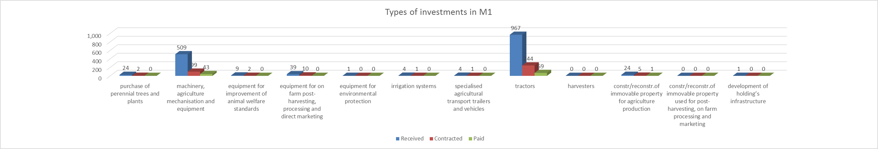

- Implementation of Measure 3
Since the start of implementation of the Programme (September 2023), only one public call was announced for this measure (01/2024 in April 2024). Due to the high interest of applicants, although the budget for the measures is higher than in previous public calls, a ranking procedure had to be applied. The process of approval of applications on this call is still open. The approval rate reaches 31% at the moment of preparation of this information.
Out of 116 submitted applications, 36 have been contracted (5.540.161 € EU funds) and 8 have been implemented and paid by November 2025 - distributing 750.311 € EU funds to the beneficiaries.
Types of agricultural production concerned by the investments in measure 3:
Type of production | Submitted  Applications  (A) | Contracted  Applications  (B) | %  (B/A) | Contracted EU part | Paid applications  (C) | %  (C/A) | Paid EU part
Milk processing | 4 | 2 | 50% | 83.803 | 0 | 0% | 0
Meat processing | 11 | 3 | 27% | 133.294 | 0 | 0% | 0
F&W processing | 31 | 6 | 19% | 1.573.457 | 0 | 0% | 0
Cereals milling | 14 | 3 | 21% | 967.740 | 0 | 0% | 0
Oils and fats | 2 | 1 | 50% | 33.957 | 0 | 0% | 0
Wineries | 15 | 2 | 13% | 213.372 | 0 | 0% | 0
Livestock feed | 2 | 0 | 0% | 0 | 0 | 0% | 0
Other Annex 1 Treaty products | 35 | 7 | 20% | 387.043 | 0 | 0% | 0
Regarding the types of activities and eligible costs financed through this measure, the IPARD Managing Authority is not able to conduct an adequate analysis of the situation since the data received from the Agency for monitoring such indicators are insufficient. For more than 80 applications the main type of investment is unknown and, as such, are reported to the IPARD Managing Authority. In this respect, improvements in the system for collection and delivery of information for implementation of the Programme in the Agency is needed.
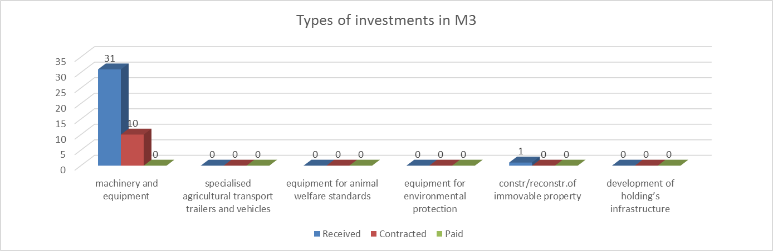

- Implementation of Measure 7
Two public calls were published for this measure. On the first public call (01/2023), the IPARD Agency approved 48 applications (EU contribution of 7.860.711 €). The approval rate reached 19 %. The number of paid applications on this call reached 24 (EU contribution of 1.726.254 €).
Approval of applications submitted on the second public call is still ongoing. By November 2025, 8 applications are contracted (EU contribution of 436.990 €) and 1 application is paid (EU contribution of 98.329 €).
Types of agricultural production concerned by the investments in measure 7:
Type of production | Submitted  Applications  (A) | Contracted  Applications  (B) | %  (B/A) | Contracted EU part | Paid applications  (C) | %  (C/A) | Paid EU part
Cultivation of mushrooms and truffles | 2 | 0 | 0% | 0 | 0 | 0% | 0
Horticulture | 3 | 1 | 33% | 18.698 | 1 |  | 18.667
Seeds and seedlings materials | 2 | 1 | 50% | 373.694 | 0 | 0% | 0
Animal breeding | 3 | 0 | 0% | 0 | 0 | 0% | 0
Bee keeping | 51 | 2 | 4% | 15.391 | 0 | 0% | 0
Herbs, spices, aromatic crops | 5 | 0 | 0% | 0 | 0 | 0% | 0
Processing of mushrooms and truffles | 3 | 0 | 0% | 0 | 0 | 0% | 0
Processing of herbs, aromatic, spices | 3 | 1 | 33% | 209.577 | 0 | 0% | 0
Production of beverages | 12 | 0 | 0% | 0 | 0 | 0% | 0
Food for pets | 94 | 20 | 21% | 2.927.016 | 8 | 9% | 583.966
Craft activities | 23 | 0 | 0% | 0 | 0 | 0% | 0
Repair and maintenance services | 6 | 1 | 0% | 312.190 | 0 | 0% | 0
Landscape services | 14 | 2 | 14% | 67.077 | 2 |  | 63.727
Residential nursing services | 3 | 2 | 67% | 855.583 | 0 | 0% | 0
Cinema, local broadcasting | 1 | 0 | 0% | 0 | 0 | 0% | 0
Veterinary services | 13 | 1 | 8% | 10.801 | 0 | 0% | 0
Repair of agri mechanization services | 2 | 0 | 0% | 0 | 0 | 0% | 0
Rental of agri mechanization services | 16 | 4 | 25% | 478.357 | 1 | 6% | 104.701
Tourist accommodation | 68 | 9 | 13% | 1.615.428 | 3 | 4% | 357.254
Catering services | 30 | 3 | 10% | 486.161 | 0 | 0% | 0
Combined services (accommodation and catering) | 23 | 3 | 13% | 585.981 | 0 | 0% | 0
Tasting rooms/selling points | 2 | 0 | 0% | 0 | 0 | 0% | 0
Seminars and trainings | 2 | 0 | 0% | 0 | 0 | 0% | 0
Recreational activities | 2 | 0 | 0% | 0 | 0 | 0% | 0
Production of energy (solar, wind, water) | 2 | 0 | 0% | 0 | 0 | 0% | 0
In this measure interest prevails in investing in the construction and reconstruction of operational facilities for the corresponding economic activities and investments in specialized equipment for processing.
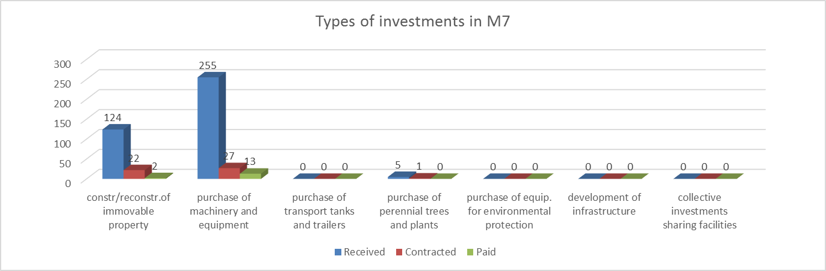

The indicators for the number of supported projects, the number of agricultural holdings/enterprises that carry out modernization projects and the number of agricultural holdings/enterprises that develop additional or diversified sources of income in rural areas have the status of November 2025. Other indicators on this chart have status as of June 30, 2025.
Data presented in the table are with cutoff date June 2025
Approval rate on previous IPARD II Programme M3 public calls: 54% - 01/2017, 60% - 01/2018, 80% - 02/2019, 66% - 01/2022 and 67% - 01/2023.
Data presented in the table are with cutoff date June 2025
Data presented in the table are with cutoff date June 2025

